University of Canberra
Faculty of Science and Technology

Software Technology 2
(7170)
Week 8 Tutorial & Computer Lab

Assignment 1: Individual Project
Part 5: Graph Data Structure and Algorithms in Python

Learning Objectives
- Understand graph representation using adjacency lists.
- Implement basic graph operations: add/remove vertices and edges.
- Apply BFS and DFS algorithms for traversal.
- Detect cycles in undirected graphs.
- Build a small visualization with Tkinter.
- Benchmark graph operations.
Outline of Tasks
Task | Concept | Key Points
1 | Graph Structure & Modification | Adding/removing vertices & edges
2 | BFS Traversal | Level-order visiting using queue
3 | DFS Traversal | Depth-first visiting using stack
4 | Cycle Detection | Recursion to detect cycles in undirected graphs
5 | Directed & Weighted Graphs | Handling edge direction and weights
6 | Visualization | GUI display
7 | Benchmarking | Performance testing
8 | Challenge Task | Extended Graph Visualiser

Task 1: Implement and Extend Graph Basics
Goal: Practice adding/removing vertices and edges.
- Create a Graph class in module graph.py
- Import the Graph class for and create Task 1 module (graph_tester.py )
- Add vertices A, B, C, D.
- Add edges between them, both directed and undirected (test both versions).
- Remove a vertex and an edge.
- Print the graph after each operation to observe changes.
- Outcome: Understand graph representation and basic modifications.
#===graph.py===
class Graph:
def __init__(self, directed=False, weighted=False):
self.graph = {} # Initialize an empty dictionary to store the adjacency list
self.weights = {}
self.directed = directed
self.weighted = weighted

def add_vertex(self, vertex):
if vertex not in self.graph:
self.graph[vertex] = [] # Add a new vertex with an empty list of edges

def add_edge(self, vertex1, vertex2, weight=0):
if vertex1 in self.graph and vertex2 in self.graph: # Check that vertices are present
# store vertex and weight as a tuple
self.graph[vertex1].append(vertex2)
if self.weighted:
self.weights[(vertex1, vertex2)] = weight
if not self.directed: # In the case of an undirected graph, append in both directions
self.graph[vertex2].append(vertex1)
if self.weighted:
self.weights[(vertex2, vertex1)] = weight
else:
print("One or both vertices not found in graph.")

#===graph_tester.py===
from graph import Graph
#Basic undirected graph tests
g = Graph()
g.add_vertex('A')
g.add_vertex('B')
g.add_vertex('C')

g.add_edge('A', 'B')
g.add_edge('B', 'C')

g.print_graph()
print()

# Directed graph tests
g = Graph(directed=True)
g.add_vertex('A')
g.add_vertex('B')
g.add_vertex('C')

g.add_edge('A', 'B')
g.add_edge('B', 'C')

g.print_graph()
print()

# Weighted graph tests
g = Graph(weighted=True, directed=True)
g.add_vertex('A')
g.add_vertex('B')
g.add_vertex('C')

g.add_edge('A', 'B', 15)
g.add_edge('B', 'C', 34)

g.print_graph()

# Removal tests
print()
print("Removal test")
removal_test = Graph()
removal_test.add_vertex('A')
removal_test.add_vertex('B')
removal_test.add_vertex('C')

removal_test.add_edge('A', 'B')
removal_test.add_edge('B', 'C')

removal_test.print_graph()

removal_test.remove_edge('A', 'B')

removal_test.print_graph()

removal_test.remove_vertex('C')

removal_test.print_graph()
print()

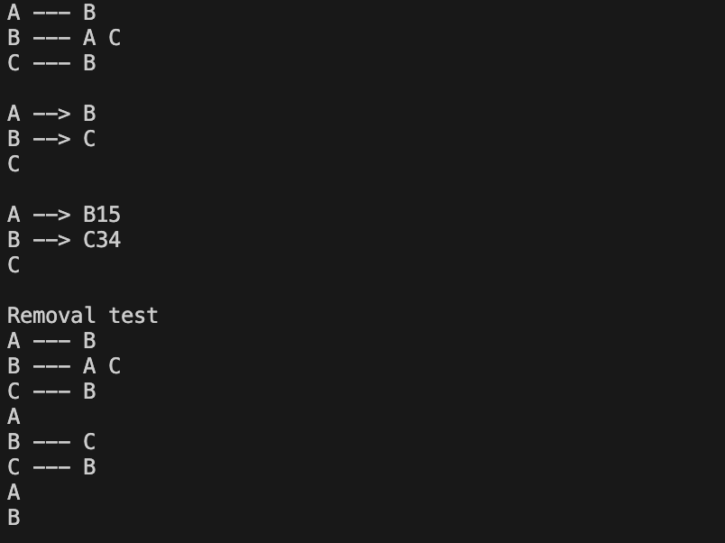

Task 2: Breadth First Search (BFS) Implementation
Goal: Explore graph traversal using BFS.
- Implement BFS starting from a given vertex.
- Add the following code to graph_tester.py to implement BFS algorithm
- Print the order of visited vertices.
- Test with a small graph (A → B → C and additional connections).
- Discuss BFS properties (level-by-level exploration).
- Outcome: Grasp BFS logic and its applications.
# BFS on the graph from Activity 1
print("BFS starting from vertex 'A':")
visited_bfs = g.bfs('A')
print("Visited vertices in BFS order:", visited_bfs)

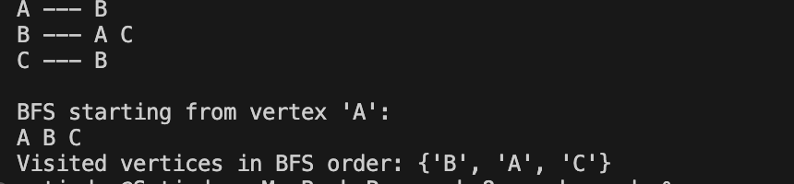

Task 3: Depth First Search (DFS) Implementation
Goal: Understand DFS differences and practice stack-based traversal.
- Implement DFS using a stack (already provided).
- Add the following code to graph_tester.py to implement DFS algorithm
- Compare output order with BFS on same graph.
- Test on branched graph including cycles.
- Outcome: Compare traversal techniques; understand search strategies.
# DFS on the same graph
print("DFS starting from vertex 'A':")
visited_dfs = g.dfs('A')
print("Visited vertices in DFS order:", visited_dfs)

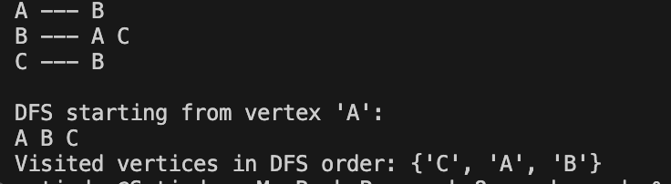

Task 4: Cycle Detection in Undirected Graphs
Goal: Write and test code to detect cycles using DFS recursion.
- Create graphs with and without cycles (triangle graph and linear chain).
- Add the following code to graph_tester.py to implement Cycle Detection algorithm in Undirectred Graphs
- Verify correct detection with boolean output.
- Outcome: Learn how DFS can detect cycles and why this matters.
#cycle detection in undirected graphs
# Create graph with a cycle
cycle_graph = Graph(directed=False)
for v in ['A', 'B', 'C']:
cycle_graph.add_vertex(v)
cycle_graph.add_edge('A', 'B')
cycle_graph.add_edge('B', 'C')
cycle_graph.add_edge('C', 'A') # Closing the cycle

print("Does cycle_graph have a cycle? ", cycle_graph.has_undirected_cycle())

# Create graph without a cycle
acyclic_graph = Graph(directed=False)
for v in ['X', 'Y', 'Z']:
acyclic_graph.add_vertex(v)
acyclic_graph.add_edge('X', 'Y')
acyclic_graph.add_edge('Y', 'Z')
print("Does acyclic_graph have a cycle? ", acyclic_graph.has_undirected_cycle())
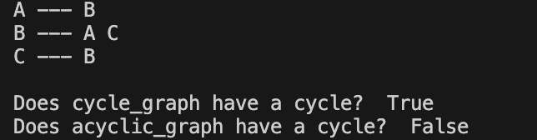

Task 5: Experiment with Weighted and Directed Graphs
Goal: Practice using weighted edges and directed graphs.
- Create a weighted directed graph with given weights.
- Add the following code to graph_tester.py to implement Weighted and Directed Graphs
- Add edges with weights (e.g., A → B with 15, B → C with 34).
- Print graph showing weights.
- Discuss how weights affect graph operations.
- Outcome: Understand storing and using edge weights.
# Create weighted directed graph
wg = Graph(directed=True, weighted=True)
for v in ['A', 'B', 'C']:
wg.add_vertex(v)
wg.add_edge('A', 'B', weight=15)
wg.add_edge('B', 'C', weight=34)
wg.add_edge('A', 'C', weight=50)
print("Weighted Directed Graph:")
wg.print_graph()

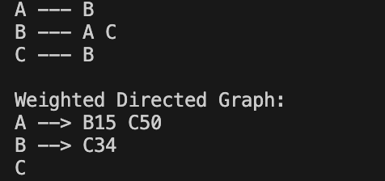

Task 6: Visualization Graph Data Structure with Tkinter
- Use Tkinter to create a simple GUI window.
- Display vertices as circles and edges as lines/arrows in a canvas.
- Implement buttons for adding/removing vertices/edges.
- Highlight BFS or DFS traversal order dynamically.
- Optional: Display edge weights near edges.
- Create a new python module (graph_visualizer.py ) and import Graph class from graph.py
# === graph_visualizer.py ===
from graph import Graph
import tkinter as tk

class GraphVisualizer(tk.Tk):
def __init__(self, graph):
super().__init__()
self.title("Graph Visualizer")
self.graph = graph
self.canvas = tk.Canvas(self, width=400, height=400, bg='white')
self.canvas.pack()
self.vertex_positions = {}
self.draw_graph()

def draw_graph(self):
self.canvas.delete("all")
radius = 20
spacing = 100
# Arrange vertices in a circle
n = len(self.graph.graph)
angle_gap = 360 / n if n else 0
center_x, center_y = 200, 200
for i, v in enumerate(self.graph.graph):
angle = i * angle_gap
x = center_x + spacing * tk.math.cos(tk.math.radians(angle))
y = center_y + spacing * tk.math.sin(tk.math.radians(angle))
self.vertex_positions[v] = (x, y)
self.canvas.create_oval(x - radius, y - radius, x + radius, y + radius, fill='lightblue')
self.canvas.create_text(x, y, text=v)

# Draw edges
for v in self.graph.graph:
x1, y1 = self.vertex_positions[v]
for nbr in self.graph.graph[v]:
x2, y2 = self.vertex_positions[nbr]
self.canvas.create_line(x1, y1, x2, y2, arrow=tk.LAST if self.graph.directed else None)
if self.graph.weighted:
w = self.graph.weights.get((v, nbr), '')
mid_x, mid_y = (x1 + x2) / 2, (y1 + y2) / 2
self.canvas.create_text(mid_x, mid_y, text=str(w), fill="red")

if __name__ == "__main__":
g = Graph(directed=True, weighted=True)
g.add_vertex('A')
g.add_vertex('B')
g.add_vertex('C')
g.add_edge('A', 'B', 10)
g.add_edge('B', 'C', 20)
g.add_edge('C', 'A', 30)

app = GraphVisualizer(g)
app.mainloop()

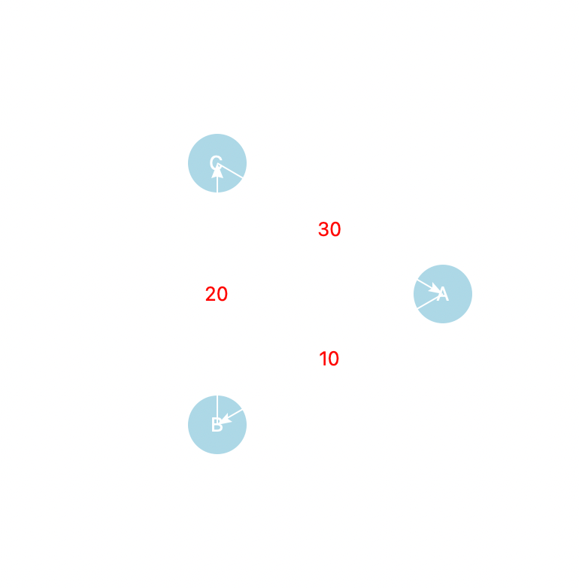

Task 7: Benchmarking Graph Operations
- Create graphs of increasing sizes (e.g., 10, 100, 1000 vertices).
- Time execution of adding vertices, adding edges, BFS, DFS.
- Print or display benchmarking results in console or GUI.
- Discuss performance implications of graph size and structure.
- Create a new python module (graph_benchmarking.py ) and import Graph class from graph.py
#===graph_benchmarking.py===
from graph import Graph
import time

def benchmark_graph_operations(num_vertices, num_edges):
g = Graph()
start_time = time.time()
for i in range(num_vertices):
g.add_vertex(str(i))
vertex_time = time.time()
print(f"Added {num_vertices} vertices in {vertex_time - start_time:.4f} seconds")

import random
edges_added = 0
for _ in range(num_edges):
v1 = str(random.randint(0, num_vertices -1))
v2 = str(random.randint(0, num_vertices -1))
if v1 != v2:
g.add_edge(v1, v2)
edges_added += 1
edge_time = time.time()
print(f"Added {edges_added} edges in {edge_time - vertex_time:.4f} seconds")

# BFS from vertex '0' if exists
if '0' in g.graph:
bfs_start = time.time()
g.bfs('0')
bfs_time = time.time()
print(f"BFS completed in {bfs_time - bfs_start:.4f} seconds")
else:
print("Vertex '0' not found for BFS")

if __name__ == "__main__":
benchmark_graph_operations(num_vertices=1000, num_edges=3000)
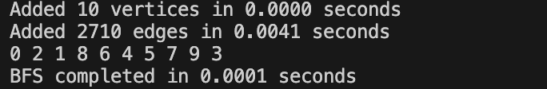
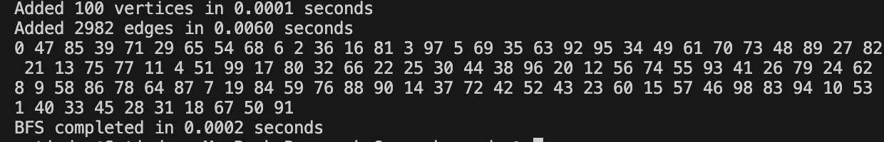
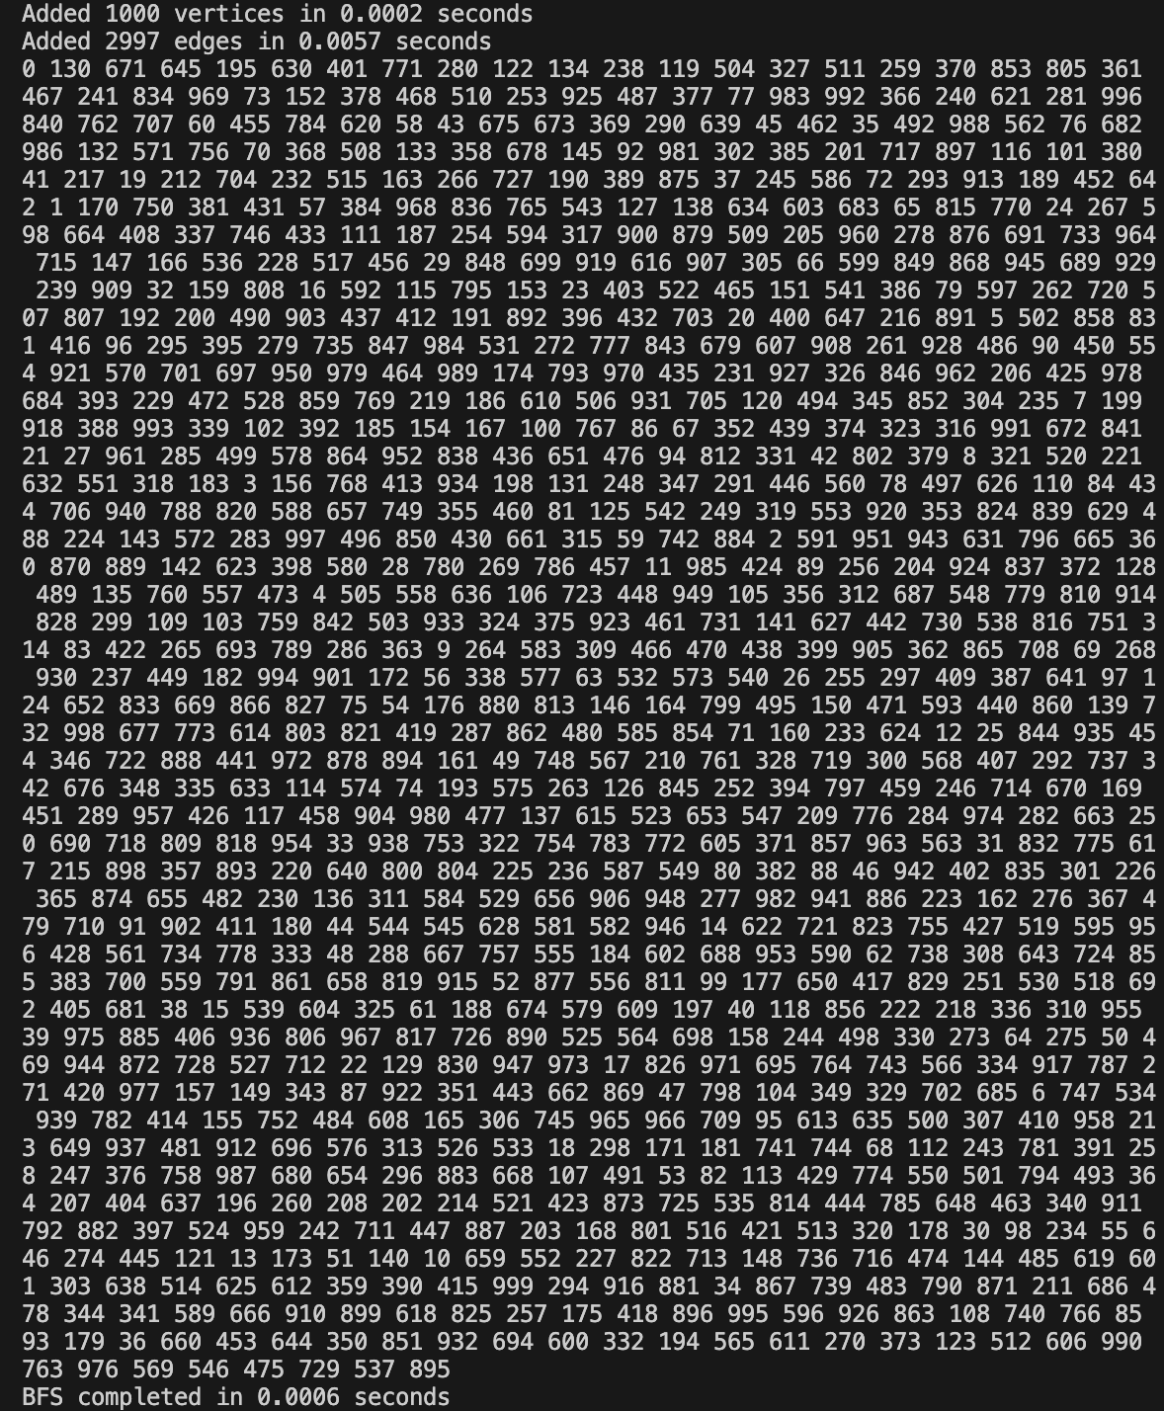
Task 8: Challenge Task- Extended Graph Data Structure Visualizer
- Implement and Visualize Directed Cycle Detection (Cycle detection in directed graphs)
- The provided graph visualizer in Task 6 includes cycle detection only for undirected graphs. Detecting cycles in directed graphs is a bit different — it requires tracking recursion stack to detect back edges.
- Task Requirements:
  - Extend the GraphVisualizer (task 6) class with to detect and visualize cycles in both directed and undirected graphs.
- Test each of the button shown in the starter template code for the graph_visualiser app shown below.

#===starter_template_code ===
#===extended_graph_visualiser.py
#===this is incomplete code which you need to complete for this #challenge task
from graph import Graph
import tkinter as tk
import math
import time
import threading

class GraphVisualizer(tk.Tk):
def __init__(self, graph):
super().__init__()
self.title("Graph Visualizer")
self.geometry('650x650')
self.graph = graph
self.canvas = tk.Canvas(self, width=600, height=600, bg='white')
self.canvas.pack(pady=10)

self.vertex_positions = {}
self.node_radius = 20
self.spacing = 180
self.center = (300, 300)
self.vertex_circles = {} # vertex -> circle id
self.edge_lines = {} # (v, nbr) -> line id

control_frame = tk.Frame(self)
control_frame.pack()

btn_bfs = tk.Button(control_frame, text="Run BFS", command=lambda: self.run_traversal("bfs"))
btn_bfs.pack(side=tk.LEFT, padx=5)

btn_dfs = tk.Button(control_frame, text="Run DFS", command=lambda: self.run_traversal("dfs"))
btn_dfs.pack(side=tk.LEFT, padx=5)

btn_cycle_undirected = tk.Button(control_frame, text="Detect Undirected Cycle",
command=self.run_cycle_detection)
btn_cycle_undirected.pack(side=tk.LEFT, padx=5)

btn_cycle_directed = tk.Button(control_frame, text="Detect Directed Cycle",
command=self.run_directed_cycle_detection)
btn_cycle_directed.pack(side=tk.LEFT, padx=5)

btn_reset = tk.Button(control_frame, text="Reset Colors", command=self.reset_colors)
btn_reset.pack(side=tk.LEFT, padx=5)

self.info_label = tk.Label(self, text="")
self.info_label.pack(pady=5)

self.draw_graph()

def draw_graph(self):
self.canvas.delete("all")
self.vertex_positions.clear()
self.vertex_circles.clear()
self.edge_lines.clear()

vertices = list(self.graph.graph.keys())
n = len(vertices)
if n == 0:
return

angle_gap = 360 / n
cx, cy = self.center

# Position vertices in a circle
for i, v in enumerate(vertices):
angle = i * angle_gap
x = cx + self.spacing * math.cos(math.radians(angle))
y = cy + self.spacing * math.sin(math.radians(angle))
self.vertex_positions[v] = (x, y)
circle_id = self.canvas.create_oval(x - self.node_radius, y - self.node_radius,
x + self.node_radius, y + self.node_radius,
fill='lightblue', outline='black', width=2)
self.vertex_circles[v] = circle_id
self.canvas.create_text(x, y, text=v, font=("Arial", 12, "bold"))

# Draw edges
for v in vertices:
x1, y1 = self.vertex_positions[v]
for nbr in self.graph.graph[v]:
x2, y2 = self.vertex_positions[nbr]

dx, dy = x2 - x1, y2 - y1
dist = math.sqrt(dx*dx + dy*dy)
if dist == 0:
continue
offset_x = dx / dist * self.node_radius
offset_y = dy / dist * self.node_radius
start = (x1 + offset_x, y1 + offset_y)
end = (x2 - offset_x, y2 - offset_y)

if self.graph.directed:
line_id = self.canvas.create_line(start[0], start[1], end[0], end[1], arrow=tk.LAST, width=2)
else:
line_id = self.canvas.create_line(start[0], start[1], end[0], end[1], width=2)

self.edge_lines[(v, nbr)] = line_id

if self.graph.weighted:
w = self.graph.weights.get((v, nbr), '')
mid_x, mid_y = (start[0] + end[0]) / 2, (start[1] + end[1]) / 2
self.canvas.create_text(mid_x, mid_y, text=str(w), fill="red", font=("Arial", 10, "italic"))

def reset_colors(self):
for v, circle_id in self.vertex_circles.items():
self.canvas.itemconfig(circle_id, fill='lightblue')
for edge_id in self.edge_lines.values():
self.canvas.itemconfig(edge_id, fill='black', width=2)
self.info_label.config(text="")

def highlight_vertex(self, vertex, color):
circle_id = self.vertex_circles.get(vertex)
if circle_id:
self.canvas.itemconfig(circle_id, fill=color)
self.update()

def highlight_edge(self, v1, v2, color):
line_id = self.edge_lines.get((v1, v2))
if line_id:
self.canvas.itemconfig(line_id, fill=color, width=3)
self.update()

def run_traversal(self, method):
def worker():
self.reset_colors()
visited = set()

start_vertex = 'A' if 'A' in self.graph.graph else next(iter(self.graph.graph), None)
if not start_vertex:
self.info_label.config(text="Graph is empty")
return

if method == "bfs":
queue = [start_vertex]
self.info_label.config(text="Running BFS...")
while queue:
vertex = queue.pop(0)
if vertex not in visited:
self.highlight_vertex(vertex, 'orange')
self.info_label.config(text=f"BFS visiting: {vertex}")
visited.add(vertex)
time.sleep(0.7)

for nbr in self.graph.graph[vertex]:
if nbr not in visited and nbr not in queue:
queue.append(nbr)
self.highlight_edge(vertex, nbr, 'green')
time.sleep(0.3)
self.info_label.config(text="BFS complete.")

elif method == "dfs":
stack = [start_vertex]
self.info_label.config(text="Running DFS...")
while stack:
vertex = stack.pop()
if vertex not in visited:
self.highlight_vertex(vertex, 'purple')
self.info_label.config(text=f"DFS visiting: {vertex}")
visited.add(vertex)
time.sleep(0.7)

for nbr in reversed(self.graph.graph[vertex]):
if nbr not in visited:
stack.append(nbr)
self.highlight_edge(vertex, nbr, 'blue')
time.sleep(0.3)
self.info_label.config(text="DFS complete.")

threading.Thread(target=worker, daemon=True).start()

def run_cycle_detection(self):
self.reset_colors()
self.info_label.config(text="Detecting cycles in undirected graph...")

if self.graph.directed:
self.info_label.config(text="Cycle detection for directed graph is not implemented.")
return

visited = set()
has_cycle = False

def cycle_dfs(current, visited_set, parent):
visited_set.add(current)
self.highlight_vertex(current, 'yellow')
self.update()
time.sleep(0.5)

for nbr in self.graph.graph[current]:
if nbr not in visited_set:
self.highlight_edge(current, nbr, 'orange')
self.update()
time.sleep(0.4)
if cycle_dfs(nbr, visited_set, current):
return True
elif parent != nbr:
self.highlight_edge(current, nbr, 'red')
self.highlight_vertex(nbr, 'red')
self.highlight_vertex(current, 'red')
self.update()
time.sleep(0.5)
return True
return False

for vertex in self.graph.graph:
if vertex not in visited:
if cycle_dfs(vertex, visited, None):
has_cycle = True
break

if has_cycle:
self.info_label.config(text="Cycle detected in the graph!")
else:
self.info_label.config(text="No cycles found in the graph.")

def run_directed_cycle_detection(self):
self.reset_colors()
if not self.graph.directed:
self.info_label.config(text="Directed cycle detection works only on directed graphs.")
return

self.info_label.config(text="Detecting cycles in directed graph...")
visited = set()
rec_stack = set()
has_cycle = False

def dfs(vertex):
nonlocal has_cycle
visited.add(vertex)
rec_stack.add(vertex)
self.highlight_vertex(vertex, 'yellow')
self.update()
time.sleep(0.5)

for nbr in self.graph.graph[vertex]:
if nbr not in visited:
self.highlight_edge(vertex, nbr, 'orange')
self.update()
time.sleep(0.5)
if dfs(nbr):
self.highlight_edge(vertex, nbr, 'red')
self.highlight_vertex(nbr, 'red')
self.highlight_vertex(vertex, 'red')
self.update()
time.sleep(0.5)
return True
elif nbr in rec_stack:
self.highlight_edge(vertex, nbr, 'red')
self.highlight_vertex(nbr, 'red')
self.highlight_vertex(vertex, 'red')
self.update()
time.sleep(0.5)
return True

rec_stack.remove(vertex)
return False

for vertex in self.graph.graph:
if vertex not in visited:
if dfs(vertex):
has_cycle = True
break

if has_cycle:
self.info_label.config(text="Cycle detected in the directed graph!")
else:
self.info_label.config(text="No cycles found in the directed graph.")

if __name__ == "__main__":
from collections import defaultdict

# Minimal Graph class implementation for testing
class Graph:
def __init__(self, directed=False, weighted=False):
self.graph = defaultdict(list)
self.weights = {}
self.directed = directed
self.weighted = weighted

def add_vertex(self, v):
if v not in self.graph:
self.graph[v] = []

def add_edge(self, v1, v2, weight=0):
if v1 in self.graph and v2 in self.graph:
self.graph[v1].append(v2)
if self.weighted:
self.weights[(v1, v2)] = weight
if not self.directed:
self.graph[v2].append(v1)
if self.weighted:
self.weights[(v2, v1)] = weight

# Create a directed graph with a cycle: A->B->C->A and extra edge C->D
g = Graph(directed=True, weighted=False)
for v in ['A', 'B', 'C', 'D']:
g.add_vertex(v)
g.add_edge('A', 'B')
g.add_edge('B', 'C')
g.add_edge('C', 'A') # Cycle here
g.add_edge('C', 'D')

app = GraphVisualizer(g)
app.mainloop()

A successful test run of this starter template code should produces the following output:

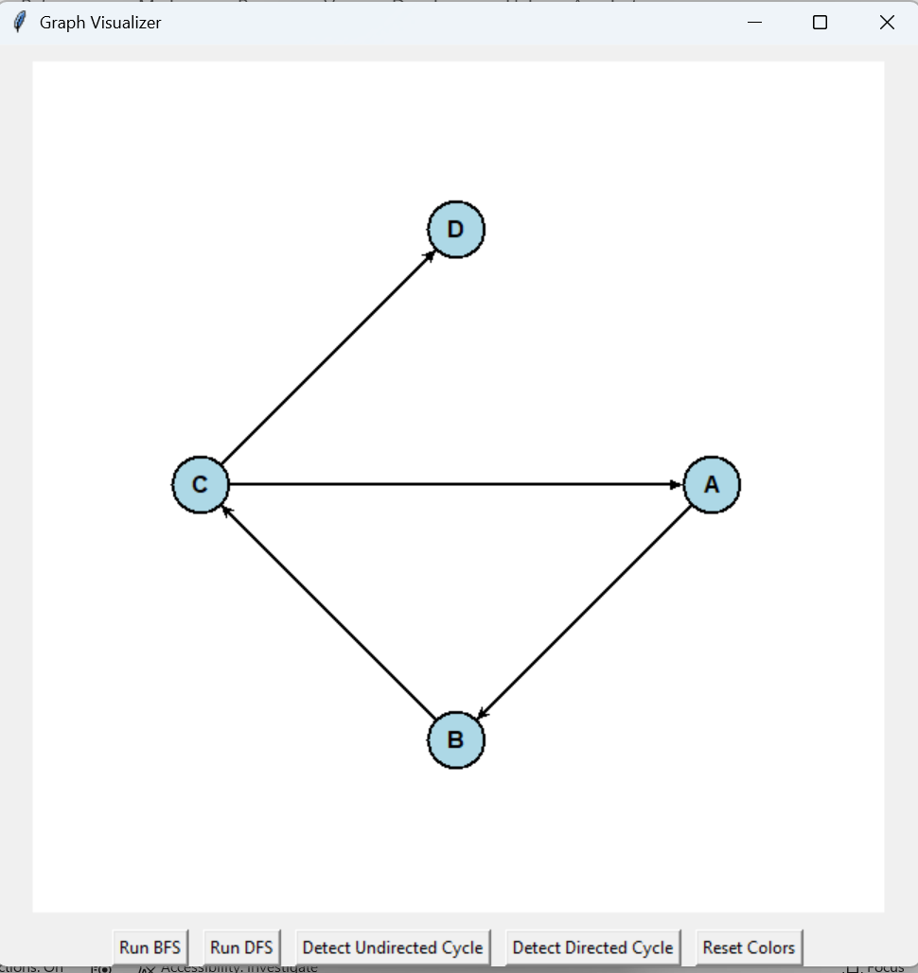
- Make a note of the results for Run BFS, Run BFS, Detect Undirected Cycle, Detect Directed Cycle and Reset Colors button presses.
- You will notice that one of the button (Detected Undirected Cycle ) button does not work.
- The challenge task for you is to fix this problem so that you can get both the detect undirected cycle and detect directed cycle button working in this app.
- The current starter template code allows :
  - Implements DFS recursion and cycle detection logic for directed graphs.
  - Allows you to practice visualization and UI updates.
  - Encourages thinking about recursion stacks for graph algorithms.
  - Builds on code you have already seen.
  - The starter code already implements directed cycle detection code and includes:
      - A button to trigger directed cycle detection.
      - Animated DFS recursion with recursion stack tracking.
      - Highlights vertices (yellow) and edges visited (orange) and those in the cycle (red).
      - Also provided Informative status messages in the UI, when cycle is detected.
  - What is missing in the starter code and what exactly needs to be implemented by you to complete this visualiser code for challenge task?
    - Update the code to make both directed and undirected cycle detection buttons working for the GraphVisualizer App
    - you need to be able to run the visualizer with two different graphs:
      - Undirected graph to test the undirected cycle detection button.
      - Directed graph to test the directed cycle detection button.
      - Because the visualizer depends on the structure of the graph passed into it, you can:
        - Create and run the app with an undirected graph when you want to test undirected cycle detection.
        - Create and run the app with a directed graph when you want to test directed cycle detection.
      - Report the results of the completed task with updated code and testing screenshots below:
